TEAM 1-K15T1-VANLANGUNI
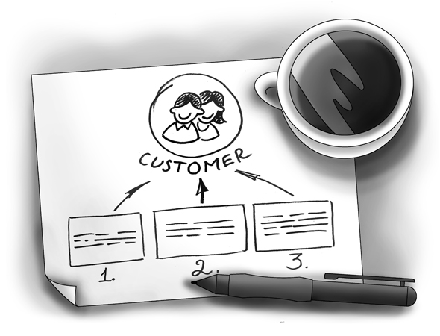
SOFTWARE REQUIREMENT SPECIFICATION
Meeting Room Booking System (MRBS)
Ver0.1
Prepared by: Team 1-K15T1-Vanlanguni
12/6/12

Team Members:
- Le Dinh Thach Huyen (Member)
- Dang Huy Son (Technical Researcher)
- Do Minh Tam (Technical Researcher & Recorder)
- Nguyen Trung Tin (Member)
- Dang Nguyen Toan (Member)
- Le Thi Bich Van (Project Manager)
Abstract:
Meeting Room Booking System is program manages the room meeting, statistic and report for IT faculty department of Van Lang University. This document describes the requirements for the Room Meeting Booking System product
Revision History
Content | Date | Author | Version
Define template and main contents | 6/12/12 | Van Le | Ver0.1
Update template and main contents | 6/16/12 | Tam Do | Ver0.2
Update content | 6/20/12 | Huyen Le | Ver0.3

Table of contents
1. Introduction 4
1.1. Purpose 4
1.2. Scope 4
1.3. Information of stakeholder for MRBS project 4
1.3.1. The customer for MRBS project 4
1.3.2. The Suppervisor for MRBS project 4
1.3.3. Our team for the project is called Team 1-K15T1-Vanlanguni and consists of 5
1.4. Definition and Acronyms 5
1.5. References 5
2. The Existing Logical System 6
3. The Proposed Logical System 6
4. System Overview 6
4.1. Product Perspective 6
4.2. User Analysis and Characteristics 6
4.3. Product Feature 7
4.4. Operating Environment 8
5. Specific Requirement 8
5.1. External Interface Requirement 8
5.1.1. User Interfaces 8
5.2. System Features 9
5.2.1. Usecase Diagram 9
5.3. Software Quality Attributes 10
5.3.1. Performance Requirements 10
5.3.2. Usability Requirements 10
5.3.3. Other Requirements 10
6. Appendix 1 10

List of figure
Figure4. 3. 1 - Requirement Breakdown Structure 8

Figure 5.1.1.1. 1 - User Interfaces Architecture 9

Figure 5.2.1. 1 - Usecase Diagram Level 1 10

List of table
Table 1. 4. 1 7

Table 4 .2 .1 7

Table 5.2.1. 1 - Usecase Description Level 1 10

Introduction
This document formally states the requirements for the RMBS product.

Purpose
The SRS document created by the team 11 provides both the functional and non-functional requirements of the Meeting Room Booking System (MRBS). This document includes definitions, specifications, and other information that will be helpful for the customer and for the team 11 to have a clear understanding of the system to be developed.
From this document, the customer will be able to understand our team’s comprehension of the requirements. This document can be updated or revised when required by the customer as we consider our customer’s demands important for our project. This document will evolve according to the requirement.

Scope
These requirements have been priority into three levels:
  - Essential
The minimum set of requirements for the product to be accepted.
  - Highly Desirable
Requirements that are considered to be likely inclusions to the product, time permitting.
  - Desirable
Requirements that are not likely to be added in this version, but should be considered for future modifications.
MRBS will help the faculty officer manages the meeting room, statistic and report for IT faculty department, use for one branch, one computer and use bar code

Information of stakeholder for MRBS project

The customer for MRBS project
Mr. Nam Vu, Teacher of Van Lang University
Phone: 0903308809
E–Mail: mailto:vuthenam@vanlanguni.edu.vn

The Suppervisor for MRBS project

Mr. Nam Vu, Teacher of Van Lang University
Phone: 090.330.8809
E–Mail: mailto:vuthenam@vanlanguni.edu.vn
Mr. Phung Bui, Teacher of Van Lang University
Phone: 090.999.7556
E–Mail: mailto:buiminhphung@vanlanguni.edu.vn

Mr. Thanh Vo, Mentor for Project Team
Phone: 090.240.5778
E–Mail: mailto:vnthanh25@gmail.com

Our team for the project is called Team 1-K15T1-Vanlanguni and consists of

Le Dinh Thach Huyen, Member
Phone: 090.918.8571
E–Mail: mailto:radinkasim@gmail.com

Dang Huy Son, Technical Researcher
Phone: 0199.8766.424
E–Mail: mailto:slavril.2009@gmail.com

Do Minh Tam, Technical Researcher & Recorder
Phone: 0126.7322.839
E–Mail: mailto:tamdo4@gmail.com
Nguyen Trung Tin, Member
Phone: 0128.4317.131
E–Mail: mailto:trungtin119@gmail.com

Dang Nguyen Toan, Member
Phone: 093.768.2000
E–Mail: mailto:dangtrannguyentoan@gmail.com
Le Thi Bich Van, Project Manager
Phone: 0985197070
E–Mail: vanbichthile@gmail.com, vanle12@vanlanguni.vn

Definition and Acronyms
No. | Term | Definition
1. | MRBS | Meeting Room Booking System
2. | SRS | Software Requirement Specification
3. | GUI | Graphical User Interface
4. | CMU | Carnegie Mellon University
5. | FC | Function
6. | FT | Feature
Table 1. 4. 1

References
HPIMS_SRS_v1.03.doc of CMU

The Existing Logical System
The client has no existing system for RMBS

The Proposed Logical System
As this is only a suggestion for the proposed logical system, all requirements mentioned in this section

System Overview

Product Perspective
MRBS is aimed toward a person who has considerable number of registry meeting room in IT department, and so needs software assistance for book meeting room and computations regarding the priority. MRBS should be user friendly, quick to learn and reliable software for above purpose

User Analysis and Characteristics
The two primary actors in MRBS are user (Faculty Officer) and Administrator
No. | Actor | Description
1. | Administrator | Administrator shall set the right to use MRBS system
2. | Faculty Officer | Faculty Officer shall manage account, borrower, room borrow, static and report, room, floor, setting system. And the faculty officer shall send out notifications through an automated email to borrower
Table 4 .2 .1

Product Feature
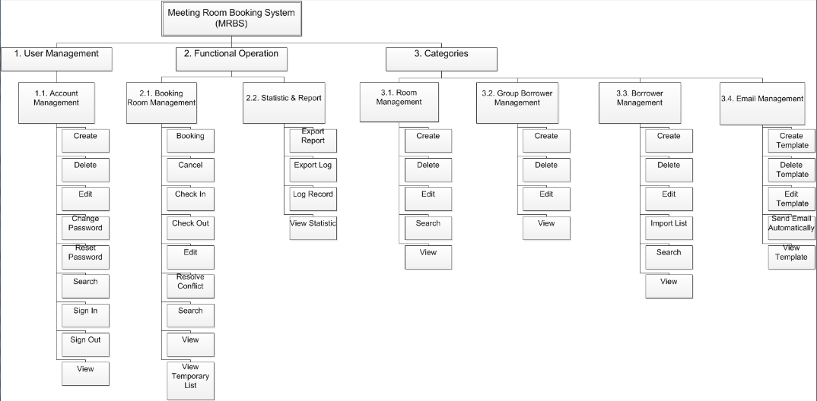
Figure4. 3. 1 - Requirement Breakdown Structure
MRBS should support the following feature:
- Account Management – Create, View, Edit, Search, Lock/Unlock, Sign In, Sign Out
  - User can create a new account, view information about the account, edit MRBS password an existing account, search, lock/unlock account, and sign in/sign out MRBS.
- Borrower Management
  - User can create a new borrower, or import a list of borrower by excel (*.xls), view, edit or search information about the borrower.
- Room Borrow Management
  - User can register a meeting room, check in/check out for borrower, change, search information about meeting room or approve/reject every request to borrow meeting room.
- Statistic and Report
  - User can view report about the meeting room, borrower violation, …
- Room Management
  - User can create a new room, and view, edit or search information about the room.
- Floor Management
  - User can create a new floor, and view, edit or search information about the floor.
- Setting – Priority, Email
  - This feature is used to set automatic priority when register the meeting room for borrower. It may be set template and send automatic email.

Operating Environment
The target system is a standalone application in a PC environment on Microsoft Windows XP, 7 with Microsoft SQL Server 2008.
The system will be developed using platform-independent C# language.

Specific Requirement

External Interface Requirement

User Interfaces
This user interface is prototype made after discussion among team 11. This will help the client to see the user interface of our final program artifact in this project. The contents and appearance can be changed or refined based on the user’s requirement and technical constraints.

User Interfaces Architecture
This is the overall architecture of MRBS prototypical user interface. The user interface is divided into three, mainly based on the functions of MRBS.
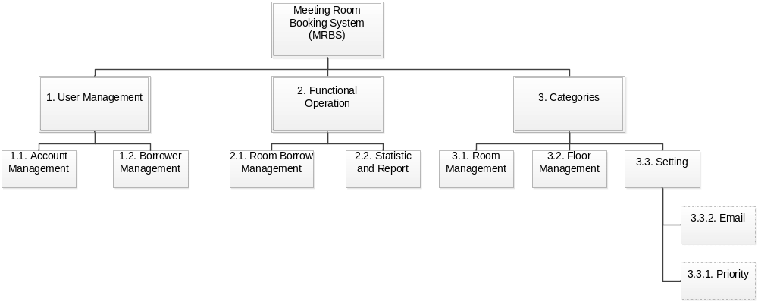
Figure 5.1.1.1. 1 - User Interfaces Architecture

System Features

Actor Table
Name | Responsibility | Role
Administrator | Administrator is a | Administrator
Booking Borrower | Booking Borrower is a | Officer Administrator

Usecase Diagram
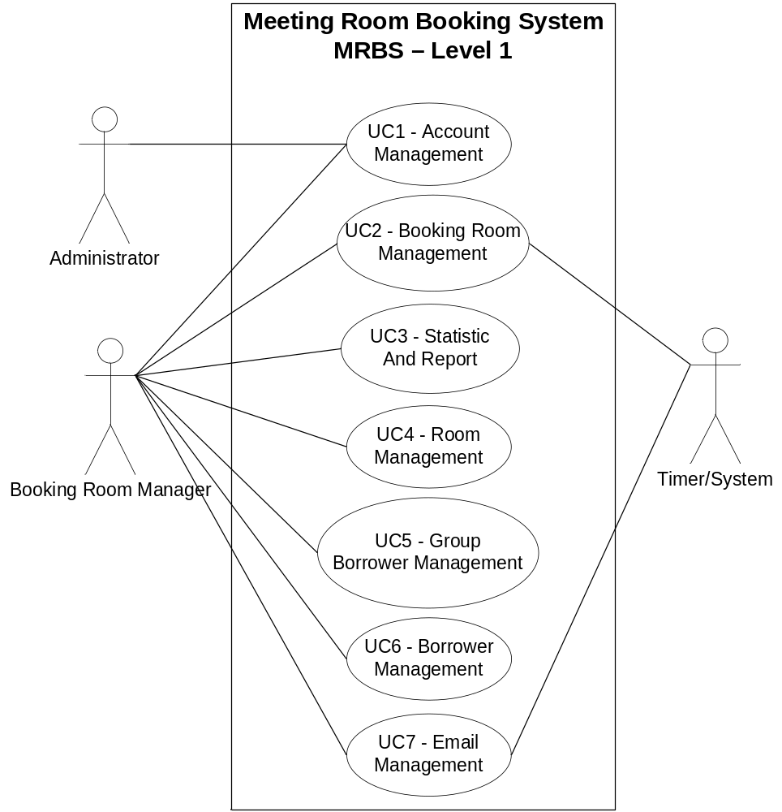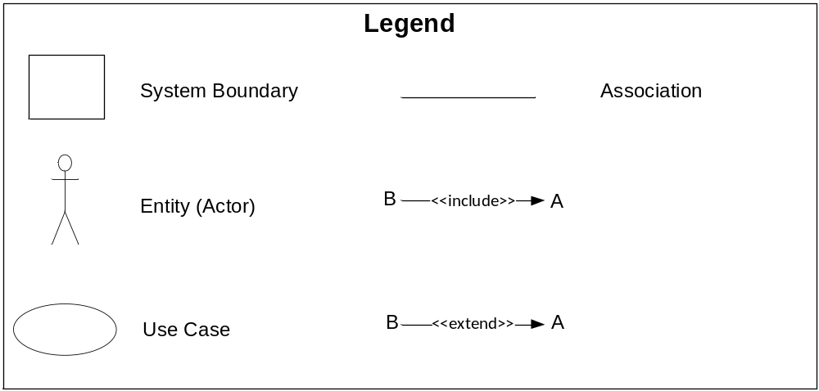 Figure 5.2.1. 1 - Usecase Diagram Level 1
      - Account Management
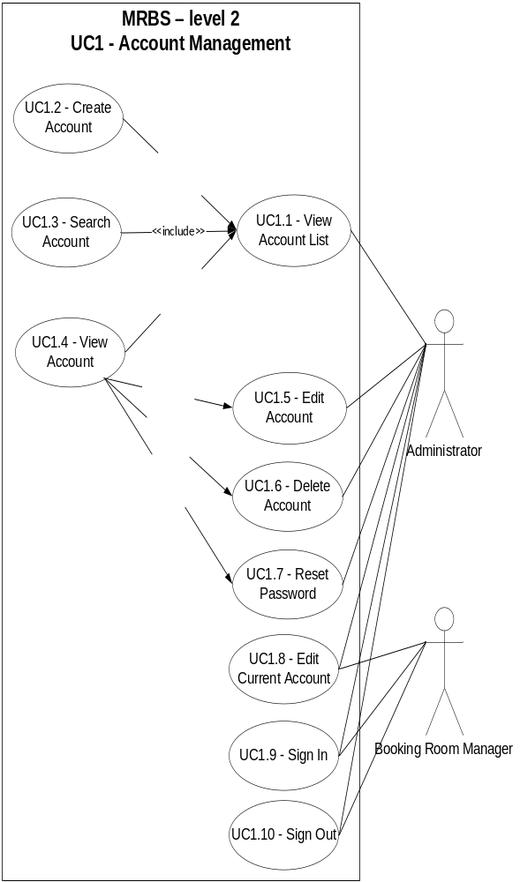
      - Booking Room Management
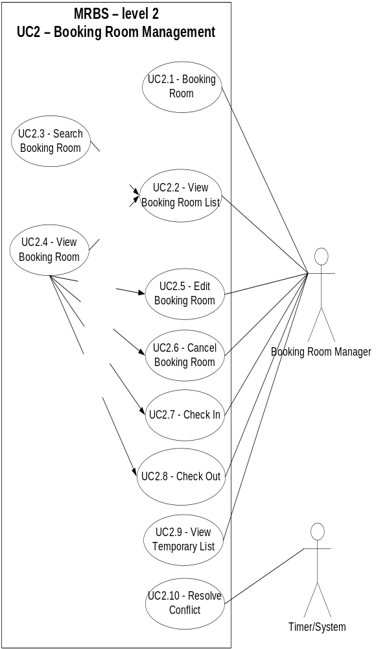
      - Statistic And Report
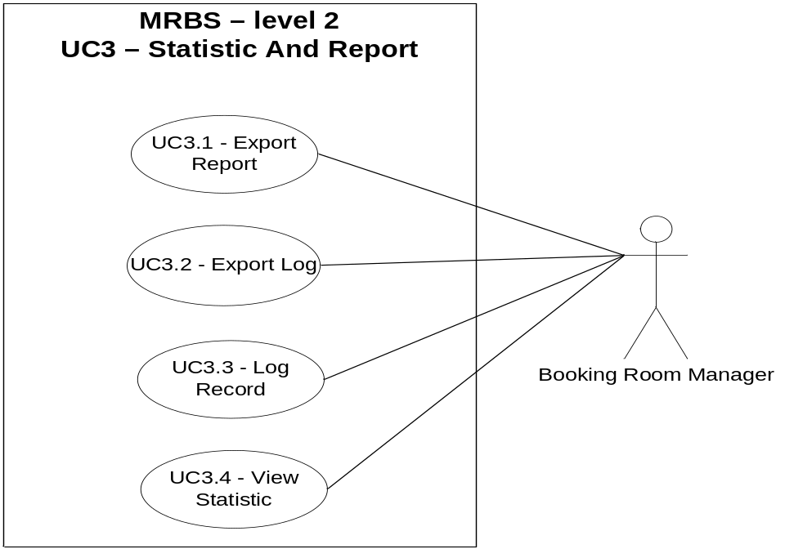
      - Room Management
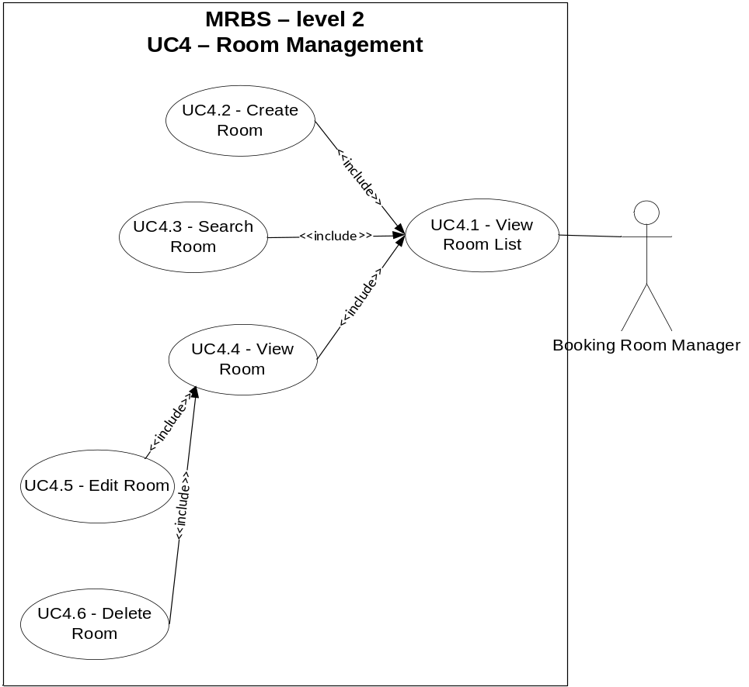
      - Group Borrower Management
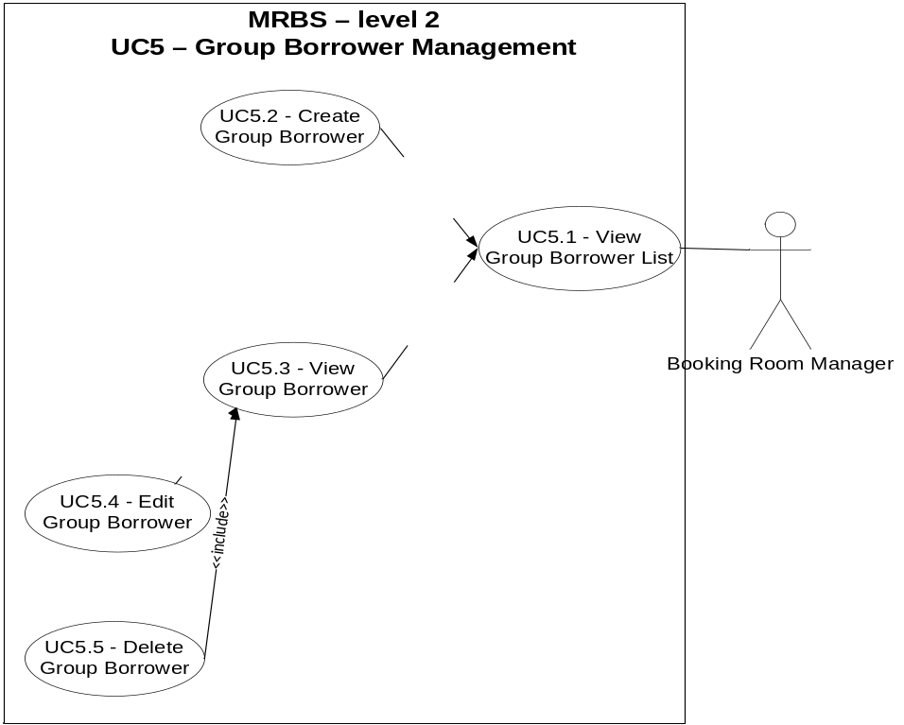
      - Borrower Management
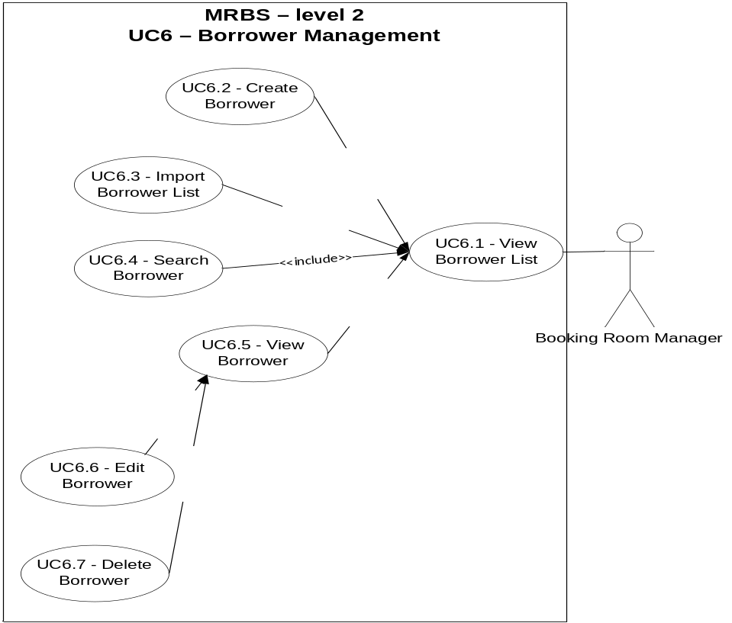
      - Email Management
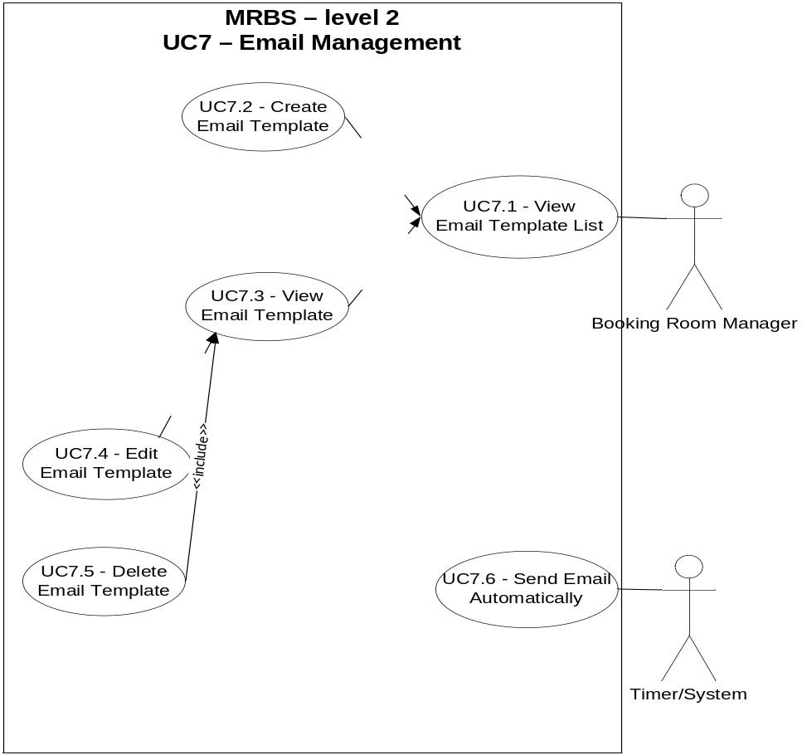
    - Use-case Table
Use Case ID | Use Cases Name | Primary Actor
Table 5.2.1. 1 - Usecase Description Level 1
    - Use-case Description
For more information, view file

Software Quality Attributes
ID | Quality Attribute Description
QA01 | Quality attribute: Performance  The program create report quickly, time is less than 5s.
QA02 | Quality attribute: Availability  System should provide availability with very small downtime periods.
QA03 | Quality attribute: Security  Password must be encrypted
QA04 | Quality attribute: Usability  The application easy to using the booking room function.

Performance Requirements

Usability Requirements

Other Requirements

Business rule
ID | Description
 | Username do not over 50 characters and do not empty
 | Do not delete user which is sign in
 | Process sign in less than 15 seconds
 | Password only letters and numbers.
 | Password not over 24 characters and do not empty
 | New password do not same as Current Password
 | Confirm Current password duplicate new password
 | File input is file excel with format

Appendix 1

